### Experiment Report 3

#### Experimental requirements and objective

1. Be able to code, assemble, and execute a program with Visual C++ and MASM.
2. Know how to link your programs to an external code library.
3. Know how to create conditional and looping structures using assembly language.

#### Experimental environment

1. Hardware environment

The microcomputer CPU more than Pentium, more than 120GB capacity hard drive, more than 1GB of memory.

1. Software environment

Visual Studio 2008 and above versions of applications.

#### Experimental contents

1. **Prime number program**
2. Write a procedure named IsPrime that sets the Zero flag if the 32-bit integer passed in the EAX register is prime.
3. Write a test program that prompts the user for an integer, calls IsPrime, and displays a message indicating whether or not the value is prime. Continue prompting the user for integers and calling IsPrime until the user enters -1.
4. **Str_remove Procedure**
5. Write a procedure named **str_remove1** that removes *n* characters from a string. Pass a pointer to the position in the string where the characters are to be removed. Pass an integer specifying the number of characters to remove. The following code, for example, shows how to remove “xxxx” from **target**:

.data

target BYTE "abcxxxxdefghijklmop",0

.code

INVOKE str_remove1, ADDR [target+3], 4

1. Write a procedure named **str_remove2** that removes *n* characters from a string. Pass an integer specifying the position in the string from where the characters are to be removed. Pass an integer specifying the number of characters to remove. The following code, for example, shows how to remove “xxxx” from **target**:

.data

target BYTE "abcxxxxdefghijklmop",0

.code

INVOKE str_remove2, ADDR target, 4, 4

1. Write a procedure named **main** that displays the string before and after removing characters.
2. **Bubble Sort**
3. Write a procedure named **BubbleSort** to perform a bubble sort on a 32-bit signed integer array whose offset address and count of elements are passed by parameters.
4. Write a procedure named **main** that creates an array of randomly ordered 32-bit integers, and display the ordered integers after calling the **BubbleSort** procedure.

#### Experiment Result

1. Prime number:

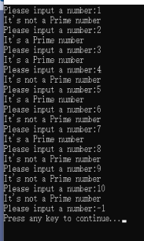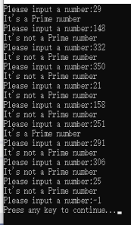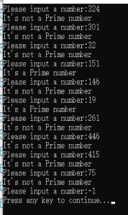

1. Str_remove procedure

(expected)

Str_remove1:



Str_remove2:



1. Bubble sort

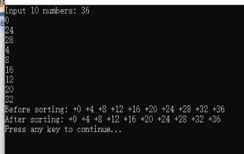

#### Source Code of Programs

1. Prime Procedure

title Prime

INCLUDE Irvine32.inc

.data

flag DWORD 0

pW BYTE "It's a Prime number",0

npW BYTE "It's not a Prime number",0

hint BYTE "Please input a number:",0

.code

Prime PROC,

val:DWORD

mov flag, 0

mov ecx, 1

cmp val, -1

jz L1

L0:

.while ecx <= val

mov edx, 0

mov eax, val

div ecx

.if edx == 0

add flag, 1

.endif

inc ecx

.endw

L1:

ret

Prime ENDP

main proc

Lp1:

mov edx, offset hint

call WriteString

call ReadInt

push eax

call Prime

mov ebx, flag

.if flag == 0

ret

.endif

cmp ebx, 2

jz L2

jnz L3

L2:

mov EDX, offset pW

call WriteString

jmp L4

L3:

mov EDX, offset npW

call WriteString

jmp L4

L4:

mov flag, 0

call Crlf

call Lp1

L5:

call WaitMsg

ret

main endp

end main

1. Str_remove

title Str_Remove

INCLUDE Irvine32.inc

.data

target BYTE "abcxxxxdefghijklmop",0

Size BYTE lengthof target

len BYTE ?

.code

Remove1 PROC,

pos:PTR BYTE,num1:WORD

mov bl, byte ptr [pos]

sub bl, byte ptr [target]

mov si, 0

.while si < bl

mov al, target[si]

call WriteChar

inc si

.endw

add si, num1

.while si < Size

mov al, target[si]

call WriteChar

inc si

.endw

ret

Remove1 endp

Remove2 PROC,

pos:PTR BYTE, num1:WORD,num2:WORD

mov si, 0

.while si < num1

mov al, target[si]

call WriteChar

inc si

.endw

add si, num2

.while si < num2

mov al,target[si]

call WriteChar

inc si

.endw

ret

Remove2 endp

main PROC

INVOKE Remove1, ADDR[target+3], 4

call Crlf

INVOKE Remove2, ADDR target, 4, 4

call Crlf

main endp

end main

1. Bubble

title Bubble

INCLUDE Irvine32.inc

.data

Data1 DWORD 10 Dup(?)

temp1 DWORD 0

temp2 DWORD 0

hint BYTE "Input 10 numbers: ",0

input BYTE "Before sorting: ",0

output BYTE "After sorting: ",0

.code

Bubble PROC,

Data: PTR DWORD

mov edx, offset input

call WriteString

mov ebx,0

mov ecx,0

.while ecx < 10

mov eax,Data

add eax,ebx

call WriteInt

mov al,' '

call WriteChar

inc ecx

add ebx,4h

.endw

mov ecx,0

mov esi,0

mov eax,0

mov edx,0

.while ecx < 10

.while esi < ecx

mov ebx, Data

add ebx, edx

mov edi, Data

add edi, eax

.if ebx < edi

mov edx,edi

mov eax,ebx

.endif

inc esi

add eax,4h

.endw

mov eax,0

mov esi,0

inc ecx

add edx,4h

.endw

mov ecx,0

mov ebx,0

mov eax,0

call Crlf

mov edx, offset output

call WriteString

.while ecx < 10

mov eax, Data

add eax, ebx

call WriteInt

mov al,' '

call WriteChar

inc ecx

add ebx,4h

.endw

call Crlf

ret

Bubble endp

main PROC

mov edx,offset hint

call WriteString

mov ecx, 0

mov ebx, 0

.while ecx < 10

call ReadInt

mov ebx, Data1

add ebx, eax

inc ecx

add ebx,4h

.endw

push Data1

call Bubble

call WaitMsg

main endp

end main

#### Summary

* How to define a procedure and then correctly call it.

Long before, we have already learnt that the format of a procedure without passing parameters is that “(procedure name) PROC … (procedure name) endp”. This time, the passing parameters are needed. And the format is as follows:

(procedure name) PROC, ;This comma is important

(parameter name) : (parameter type), …, (parameter name) : (parameter type)

Also, when calling a procedure, notice that whether passing parameters are matched with the define type. Otherwise, the whole program cannot pass the compilation.

* Two types of calling a procedure

The first type is pushing the parameters into the stack, then use the “call” keyword. And the second type is, use the “invoke” keyword with the parameters behind.

After this experiment, the most impressive idea is, if the number of parameters is not too much, use the “push” and “call”, or else, choose to use the “invoke” keyword.

* Classification of address and content

Notice that the common register can store both the address and content, it’s quite easy to mixture them. Thus, the strategy is store the address in common register, for example, store in the “eax” accumulator, then [eax] is the value stored in the address and can be operated.

* Module

Actually, we code with the pseudocode, and it helps us done lots of things like implicitly push and so on. The most classical example is as follows:

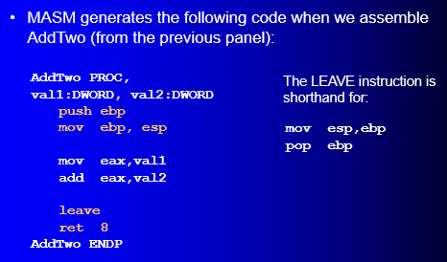

* At the end

Sincerely thanks for teaching, maybe it’s a bit hard for us to absorb all the content of the course. However, teacher always use the examples to help us to get a better understanding after learning the theory with great patience. Once again, thanks for the teaching.